Your LOGO HERE
Presents:
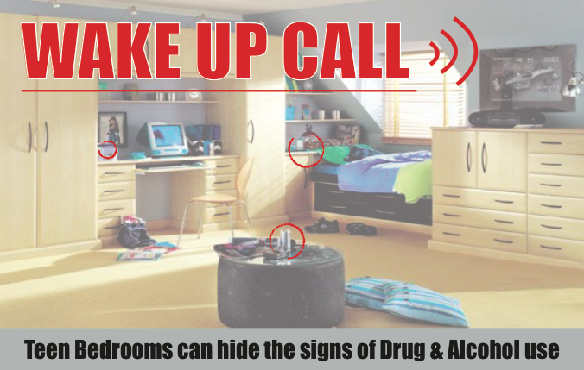
Wake-Up Call is a life-size exhibit of a teen’s bedroom with more than 20 “red flags” that can signal drug or alcohol use. The bedroom identifies spots where teens may hide drugs, household items that can be used as drug paraphernalia and ways teens try to cover up drug and alcohol use. Our goal is to educate parents and other adults who are influential in the lives of youth so they know what seemingly innocent items can actually be an indication of substance abuse.

The Wake Up Call presentation will take place:
Date

6:00-6:30 PM Resource Fair
6:30-8:00 PM Wake Up Call tour presented by
PRESENTERS
School
Address
City, State Zip
Please register for this FREE event at https://wxxxxxxxxxxxxxx.eventbrite.com For questions about this event, please contact

Contact person at (xxx) xxx-xxxx,
email or
Contact person at (xxx) xxx-xxxx

This presentation is for adults only (21 years of age and over)

Sponsored By:

